**Metaverse In E-Commerce**

For centuries, the only viable marketplace (except for a “Sears'' catalog back in my parents’ time) was physical-to-physical (P2P). Customers went to a physical location, selected a product and exchanged physical “fiat” money in person for the material goods they wanted.

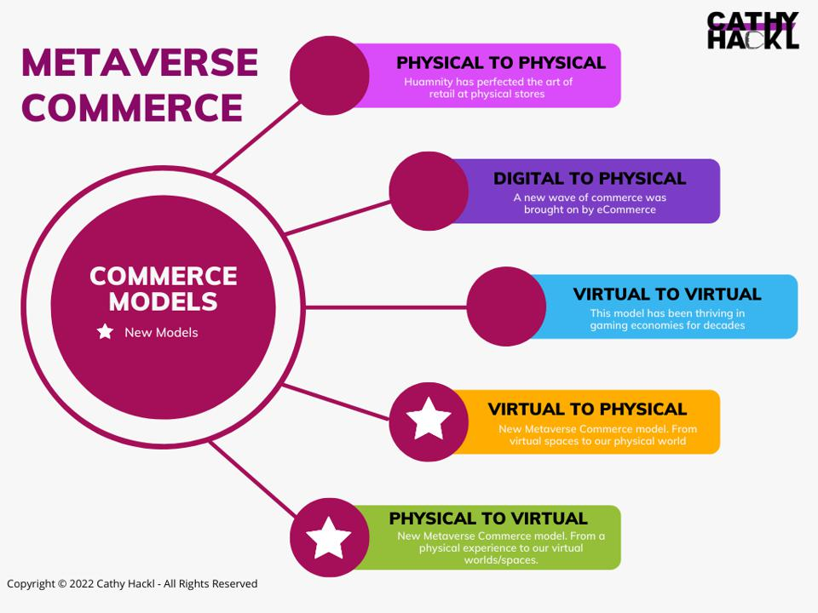

The dawn of the internet introduced new marketplaces for exchanges starting with social media apps and eCommerce. In the dawn of the metaverse and the coming era of web3, commerce will evolve and with this evolution, new models will emerge.

The marketing strategies, and even the products that brands will sell, will be different as we head into the successor state to today’s mobile internet, the metaverse. Whether the products are physical or virtual, professionals will have to consider demographic and psychographic data, skill-building and gamification, user interaction, events/experiences, digital twin technologies, and creating a unified commerce front…all with the intent of encouraging engagement with a product or service. Then add a layer of complexity to the mix when you factor in the importance of community, fandom, and authenticity and their impact on a fan and/or customer’s choices in the physical and virtual realms.

Many professionals use the term in-person shopping to differentiate it from virtual. I would suggest that all shopping is in-person, even if it’s done on a virtual platform or for the benefit of an avatar or a virtual home. There is still a human behind the decision making and the final purchase! (at least for now)



According to a research “brands that do want to spend some of their marketing dollars on Metaverse tech should look for things that already work and then figure out how to make them even better with immersive tech.” Moreover, brands should start this process as soon as possible since the “new” costumer is already there. “The key is to engage consumers with entertaining and accessible digital content that lowers the barriers to entry and meets Metaverse users where they already exist,”

**Making It A Reality**



Current shopping models are Physical-to-Physical, Digital-to-Physical, and Virtual-to-Virtual. But what about going the next step and making the sale from Virtual-to-Physical and Physical-to-Virtual? When your customers are in the Metaverse, it’s virtual first. However, what happens when they want to purchase something physical in-game or in-world? Or when they are at a physical location, whether a store or a music festival and something they acquire at the location can unlock something else for them in the virtual world? We will dive deeper into these models later in this essay and in future ones.

In the Metaverse, there is an emerging business model focused on providing new products to digital twins of the customer, which would be the person’s unique avatar. This is called [Direct-to-Avatar](https://www.forbes.com/sites/cathyhackl/2020/08/09/is-direct-to-avatar-the-next-direct-to-consumer/?sh=1e63de2d102a)(D2A), a term that [Ryan Gill](https://www.linkedin.com/in/ryanagill/), CEO of Crucible, and I first explored back in July 2020 in a highly cited article. D2A bypasses traditional marketing by focusing on in-game personas to sell virtual goods, physical items, or real-world experiences. D2A may sound counterintuitive, but it is becoming a fast-growing market segment with an increased sense of connection to purchase digital goods that may or may not come with real-world counterparts. D2A can be leveraged by brands to sell V2V, P2V, and V2P.

With D2A becoming a new model for D2C, this in itself signals a new frontier for B2B and B2C paradigms which will be impacted not only by gaming but also by AR and voice.

## ****The Wave Of The Future Is Coming To Shore****

